Epsom & Ewell F.C.
10
v
Chertsey Town
Tuesday, 28th October 2014
For our League match this evening we welcome the players, officials and supporters of Chertsey Town, along with today's match officials and of course our own regular supporters.

Today’s visitors have suffered a particularly harrowing start to the season, having dropped down from the Southern League in May. I am sure that they hoped to be able to bounce back, but along with Guildford City they have found things a bit tougher than they were a few years ago when those two teams “ruled the League” so to speak.

We have of course met on many occasions going back all the way to the late forties, and although we won our last meeting; a Surrey Senior Cup tie last season, it was not likely to have been a full strength team that we faced as it would not have been as important as their battle for League survival back then. Overall, we have a fairly poor record against them, although many supporters will recall a famous 3-2 win back in September 2009 with the last minute winner after trailing 2-0.

Our last home game was at home to Ashford Town (Middlesex) and we had a good go at them, but ultimately came up short by four goals to two. I actually thought we looked quite good in patches against a team that had a very strong defensive record.

We followed that with a trip to Camberley Town where we were edged out by a goal to nil. Although these two matches may have ended in defeat, we were not outclassed in either and we can hopefully take those positives into tonight’s game and those to follow.

This Saturday we visit Lingfield for a First Round F.A. Vase tie. With £900 to the winning team and an opportunity for progress, the exemption to this stage was earned by our third place finish last season. Hopefully when we are next gathered here I shall be able to report on a fine result.

However, the date of our next home game is in doubt right now. We are technically scheduled to host Molesey here on Saturday 22nd November, although if we were to win at Lingfield, that day is when the next round of the Vase will be played. Molesey are already out, so we definitely have a game, but if we do get through and are drawn away, we won’t be here again until Tuesday 2nd December when we host Camberley Town in the Surrey Senior Cup.

We also have a fortnight off between 1st and 15th November, assuming no Vase replay with Lingfield and our Frimley Green League Cup visit is on Tuesday 9th December. Additionally, the rearranged League game with Spelthorne Sports will take place here on Tuesday 16th December. Please keep checking the website www.eefconline.co.uk for amendments.

Thanks for coming to watch. The club, Glyn and the boys value your support.

Enjoy the game!

Rich (Richard.c.lambert@gmail.com) on Twitter @EEFCOfficial

Cover photo this week by Gemma Jarman

Matt Ferdinando scores our second goal
in the League match against Ashford on 18th October

Cherry Red Records
Combined Counties League
Premier Division Table 2014/15
inc 25th October 2014 | P | W | D | L | F | A | Pts | GD | H | A
Cove | 15 | 12 | 2 | 1 | 35 | 18 | 38 | +17 | 7/3 | 15/11
Ashford Town (Mx) | 14 | 12 | 1 | 1 | 39 | 10 | 37 | +29 | 2-4 | 10/1
Molesey | 13 | 10 | 0 | 3 | 47 | 15 | 30 | +32 | 22/11 | 28/2
Camberley Town | 15 | 9 | 3 | 3 | 30 | 10 | 30 | +20 | 7/2 | 0-1
Windsor | 13 | 9 | 2 | 2 | 34 | 12 | 29 | +22 | 3/1 | 11/4
Spelthorne Sports | 13 | 8 | 2 | 3 | 24 | 17 | 26 | +7 | 11/11 | 3-0
Epsom & Ewell | 15 | 6 | 2 | 7 | 26 | 22 | 20 | +4 | X | X
Colliers Wood United | 15 | 6 | 2 | 7 | 25 | 25 | 20 | 0 | 4/4 | 2-3
Mole Valley SCR | 15 | 5 | 4 | 6 | 28 | 31 | 19 | -3 | 1-0 | 18/11
Hartley Wintney | 12 | 6 | 1 | 5 | 13 | 16 | 19 | -3 | 21/2 | 1-2
Frimley Green | 14 | 5 | 4 | 5 | 26 | 30 | 19 | -4 | 0-0 | 25/4
Bedfont Sports | 14 | 6 | 1 | 7 | 20 | 27 | 19 | -7 | 0-1 | 20/12
Raynes Park Vale | 13 | 5 | 3 | 5 | 17 | 19 | 18 | -2 | 0-1 | 27/12
Horley Town | 16 | 4 | 4 | 8 | 30 | 36 | 16 | -6 | 2-2 | 6/4
Farnham Town | 16 | 4 | 4 | 8 | 23 | 33 | 16 | -10 | 17/1 | 2-0
Badshot Lea | 15 | 4 | 3 | 8 | 23 | 32 | 15 | -9 | 21/3 | 13/12
Knaphill | 15 | 4 | 3 | 8 | 17 | 40 | 15 | -23 | 18/4 | 4-1
Chertsey Town | 14 | 4 | 1 | 9 | 18 | 32 | 13 | -14 | 28/10 | 14/3
Westfield | 15 | 3 | 3 | 9 | 18 | 29 | 12 | -11 | 31/1 | 0-4
Guildford City | 16 | 3 | 1 | 12 | 24 | 47 | 10 | -23 | 4-1 | 29/11
Hanworth Villa | 14 | 2 | 2 | 10 | 15 | 31 | 8 | -16 | 6/12 | 5-2

Lucky Day? – 28th October
Played 14 - Won 3 Drawn 3 Lost 8 - F 24 A 27 - PPG 0.86 - Awful
Club record against Chertsey Town
Played 43 - Won 15 Drawn 5 Lost 23 - F 62 A 79 - PPG 1.16 - Below Average
Last visit
Tuesday 22nd October 2013 - Won 1-0 - Surrey Senior Cup

First Eleven Appearances - (max 19 inc Camberley)
Name | Debut | 2014/15 |  |  |  | Career Totals
 |  | App | Sub | Total | Goals | App | Sub | Total | Goals
BROWN Oshane* | 30/08/2014 | 2 | 0 | 2 | 0 | 2 | 0 | 2 | 0
CURRIE Sam | 04/08/2012 | 2 | 0 | 2 | 0 | 96 | 5 | 101 | 2
DEAN Dan | 02/08/2014 | 16 | 0 | 16 | 0 | 16 | 0 | 16 | 0
DEWAR Ali | 29/10/2011 | 5 | 2 | 7 | 3 | 55 | 31 | 86 | 10
DOUGLIN Karl* | 03/08/2013 | 1 | 0 | 1 | 1 | 41 | 3 | 44 | 14
DOWNS Carl* | 17/09/2011 | 4 | 1 | 5 | 0 | 94 | 13 | 107 | 2
EACOTT Michael | 02/08/2014 | 17 | 0 | 17 | 0 | 17 | 0 | 17 | 0
FARRELL Matt | 02/08/2014 | 18 | 1 | 19 | 2 | 18 | 1 | 19 | 2
FERDINANDO Matt | 20/09/2014 | 6 | 3 | 9 | 1 | 6 | 3 | 9 | 1
GAFFNEY Luke | 16/08/2014 | 9 | 1 | 10 | 0 | 9 | 1 | 10 | 0
HARPER Tommy | 15/04/2014 | 1 | 0 | 1 | 0 | 2 | 1 | 3 | 0
HAYWARD Ben | 07/03/2007 | 5 | 0 | 5 | 0 | 241 | 28 | 269 | 18
HOADLEY Harry | 15/04/2014 | 6 | 1 | 7 | 0 | 7 | 1 | 8 | 0
HOUGH Kyle | 14/08/2007 | 17 | 0 | 17 | 5 | 271 | 12 | 283 | 142
JARMAN Mark | 08/08/2009 | 3 | 5 | 8 | 0 | 134 | 51 | 185 | 76
MARVELL Dale | 15/01/2000 | 10 | 5 | 15 | 5 | 260 | 45 | 305 | 85
MURPHY George | 28/03/2013 | 14 | 1 | 15 | 1 | 55 | 5 | 60 | 3
MUTIMA Lionel | 05/08/2014 | 4 | 2 | 6 | 0 | 4 | 2 | 6 | 0
NELMES Elliott* | 05/08/2014 | 2 | 0 | 2 | 0 | 2 | 0 | 2 | 0
PANAYI Anthony | 14/11/2010 | 11 | 1 | 12 | 0 | 138 | 15 | 153 | 4
ROBINSON Matt | 01/12/2012 | 4 | 1 | 5 | 0 | 5 | 4 | 9 | 1
ROBINSON Sam | 22/10/2011 | 12 | 1 | 13 | 5 | 36 | 4 | 40 | 10
SHAW Ollie | 20/09/2014 | 0 | 7 | 7 | 0 | 0 | 7 | 7 | 0
SMITH Taylor | 02/08/2014 | 12 | 0 | 12 | 5 | 12 | 0 | 12 | 5
TANTON Matt | 02/08/2014 | 11 | 2 | 13 | 1 | 11 | 2 | 13 | 1
TAYLOR James | 26/08/2013 | 12 | 1 | 13 | 1 | 29 | 7 | 36 | 2
VAN GELDER Julian* | 12/09/2006 | 0 | 1 | 1 | 0 | 0 | 2 | 2 | 0
WHITE Sean | 02/08/2014 | 5 | 7 | 12 | 2 | 5 | 7 | 12 | 2
Own Goal |  |  |  |  | 1
* Player has left the club

Results and Fixtures
Combined Counties League – Saturday 18th October
Badshot Lea | 5-0 | Knaphill
Camberley Town | 3-0 | Raynes Park Vale
Epsom & Ewell | 2-4 | Ashford Town (Mx)
Frimley Green | 3-1 | Westfield
Guildford City | 2-3 | Bedfont Sports
Hartley Wintney | 1-2 | Farnham Town
Horley Town | 1-5 | Molesey
Mole Valley SCR | 1-0 | Colliers Wood United
Spelthorne Sports | 3-2 | Cove
Windsor | 2-0 | Hanworth Villa
Combined Counties League Cup Second Round – Tuesday 21st October
Eversley & California | 2-4 | Ash United
Westfield | 4-0 | Farleigh Rovers
Surrey Senior Cup First Round – Tuesday 21st October
Raynes Park Vale | 2-0 | Chertsey Town
South Park | 2-1 | Guildford City
Combined Counties League – Tuesday 21st October
Hartley Wintney | 0-4 | Windsor
Mole Valley SCR | 2-5 | Horley Town
Surrey Senior Cup First Round – Wednesday 22nd October
Croydon | 0-0+ | Colliers Wood United
Colliers Wood United win 4-3 on penalties
Combined Counties League – Saturday 25th October
Ashford Town (Mx) | 3-1 | Mole Valley SCR
Bedfont Sports | 1-2 | Hartley Wintney
Camberley Town | 1-0 | Epsom & Ewell
Colliers Wood United | 2-3 | Badshot Lea
Cove | 2-1 | Horley Town
Farnham Town | 2-1 | Spelthorne Sports
Hanworth Villa | 2-0 | Chertsey Town
Molesey | 2-3 | Guildford City
Raynes Park Vale | 4-0 | Frimley Green
Westfield | 1-2 | Knaphill
Combined Counties League – Tuesday 28th October
Epsom & Ewell | V | Chertsey Town
Mole Valley SCR | V | Hartley Wintney
Westfield | V | Windsor
F.A. Vase First Round – Saturday 1st November
Ashford Town (Mx) | V | Loxwood
Results and Fixtures
F.A. Vase First Round – Saturday 1st November
Colliers Wood United | V | Ringmer
Chertsey Town | V | Horley Town
Chessington & Hook United | V | Camberley Town
Farnham Town | V | Abingdon United
Lingfield | V | Epsom & Ewell
Littlehampton | V | Guildford City
Lordswood | V | Knaphill
Pagham | V | Spelthorne Sports
Raynes Park Vale | V | Westfield
Windsor | V | Highworth Town
Combined Counties League – Saturday 1st November
Badshot Lea | V | Mole Valley SCR
Frimley Green | V | Hartley Wintney
F.A. Vase First Round – Sunday 2nd November
Horsham YMCA | V | Bedfont Sports
Combined Counties League Cup Second Round – Tuesday 4th November
Cobham | V | Horley Town
Surrey Senior Cup Second Round – Tuesday 4th November
Woking | V | Ashford Town (Mx)
Combined Counties League – Tuesday 4th November
Badshot Lea | V | Hartley Wintney
Bedfont Sports | V | Raynes Park Vale
Spelthorne Sports | V | Molesey
Westfield | V | Camberley Town
Combined Counties League – Saturday 8th November
Badshot Lea | V | Molesey
Camberley Town | V | Hanworth Villa
Colliers Wood United | V | Guildford City
Farnham Town | V | Windsor
Frimley Green | V | Cove
Hartley Wintney | V | Ashford Town (Mx)
Knaphill | V | Mole Valley SCR
Raynes Park Vale | V | Westfield
Spelthorne Sports | V | Chertsey Town
Combined Counties League Cup Second Round – Tuesday 11th November
Hanworth Villa | V | Guildford City
Combined Counties League – Tuesday 11th November
Cove | V | Raynes Park Vale
Molesey | V | Windsor

From behind the goal
Epsom & Ewell 2-4 Ashford Town (Mx)
Combined Counties League – Premier Division
Saturday 18th October 2014

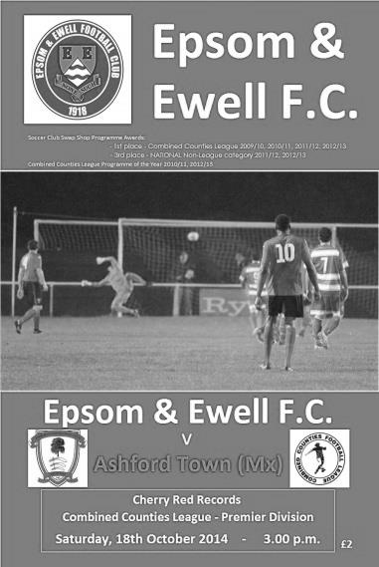
Ashford have just too much for the Salts

After a season where we had so far avoided many of the top teams, we faced second placed Ashford Town (Middlesex) at High Road, and although defeated, we became the first side to score twice against them since their opening day defeat and remained competitive throughout with the visitors only confirming their win three minutes from time.

We continued with Tuesday's formation as Glyn named an unchanged eleven, although the opening exchanges were fairly even with nothing memorable to report. Unfortunately the first thing I had to write down was the opening goal for the visitors, which was scored in rather frustrating circumstances. An Ashford free kick for offside was taken to a team mate who then picked the ball up, clearly intending to take the kick further infield. Whether or not this was handball is a matter of opinion, but our players heard a whistle and rushed towards the ball. However, the referee had not blown for a handball, he had blown to indicate the free kick to Ashford and it was then quickly taken with our players out of position, and although we did regain possession briefly, Dan Dean's clearance was charged down by Dan Fleming who then reached the loose ball just ahead of Michael Eacott to score in the fifteenth minute.

With Ashford's excellent defensive record (seven goals conceded in twelve League matches) you felt that it would be difficult to bounce back, especially with two big attacking threats Taylor Smith and Dale Marvell absent. Their two central defenders Jack Mullen and Russell Canderton were getting to everything first, even when they didn't really want to, but more of that later. In trying to pull the goal back, Matt Farrell headed just over the bar from a Dean cross from the left that the visiting keeper Tyler Tobin had misjudged, clearly not realising that Farrell would reach it. Then Matt Robinson was brought down in the act of shooting and brother Sam fired a powerful free kick but it was blocked by Alex Fisher and cleared. Then after 33 minutes Sam Robinson tried his luck from twenty five yards but unlike his stunning goal on Tuesday his shot cleared the bar by a couple of feet with Tobin beaten.

The visitors were not without threat and they could have scored a second when a low shot was just wide of Eacott's right hand post before a bout of panic defending deep in our area which was a bit nervy. Still we then broke away and Matt Robinson, linking well with Kyle Hough set him through on the left. He got there ahead of Tobin, and as the keeper slipped

he headed for goal, clearly looking for a shot. However, the angle was not great and he squared the ball for one of our players to strike, only for Mullen to get there first and volley the ball into his own net from six yards for our equaliser in the 39th minute.

We have a young side ad occasionally they will make what Americans would call "rookie mistakes". Unfortunately it was one of these that caused our undoing less than a minute later. We pressed, full of confidence after scoring, but the ball fell to Matt Ferdinando on the edge of the area and with three players left of him, he tried something different and lost the ball, leaving us badly exposed on the counter attack. As the ball spread left our remaining players got dragged across so that when the ball was played back out to the right, Mark Bitmead was there on his own to stroke the ball past Eacott for Ashford to restore their lead. It got worse three minutes later when more space was found on the right and the ball was played in for Fleming to score his second goal and Ashford's third in the 43rd minute.

We had a scare at the start of the second half when a right footed shot from the visitors went out for a goal kick after striking our post but we were soon back on the attack, and after 51 minutes a poor defensive header was intercepted by Hough who went wide but found his effort blocked low by Tobin. Hough had another half chance minutes later when Sam Robinson put him through but he was wide and screwed his shot across goal, but too far ahead of the advancing Sean White who by now had moved more from a wing back to an outright winger by this stage.

After 65 minutes we had another winger on as Ali Dewar went on the left wing in relief of Gaffney. It was good to see him back after illness and he made some dangerous passes in the time he was on the pitch. In the 68th minute it was Mullen's defensive partner Canderton that reached one of Dewar's low crosses ahead of the rest but like Mullen he turned it goalwards by accident, requiring Tobin to make his smartest save of the game.

We continued to press and were rewarded for our endeavours after 75 minutes when a deep right wing cross from White was headed back across goal by Sam Robinson and the incoming Ferdinando was able to glance the ball over the line for his first goal for the club. Hough's next chance from a Dewar cross was just too high for him and he was unable to get the header on target. Robinson then got a low volley on target but with Epsom players rushing in for any fumble, Tobin did well to hold on to the ball.

Eacott was back in action; having tipped over a free kick earlier, his low save from another Fleming attempt was superb. However, their striker was not to be denied his hat trick when he found some space in the 87th minute and buried his shot clinically.

There was one final incident of note which soured the atmosphere which was when Ashford substitute Conor Moody made a very late challenge on Eacott that left him requiring treatment. The referee produced the straight red card, although the sight of some of the visiting supporters applauding him off the pitch following his virtual assault was a bit classless. It was a pity that such an entertaining encounter would end that way. On balance I feel that the visitors deserved the three points but over the game we gave them much to think about and with a little more composure and experience we would have been the team winning this match. We'll see if we can get any closer when we meet again in January.

Team: Michael Eacott, Sean White, Luke Gaffney, George Murphy, Anthony Panayi ©, Dan Dean, Matt Ferdinando, Matt Farrell, Matt Robinson, Kyle Hough, Sam Robinson

Subs: Ali Dewar for Gaffney (65), Mark Jarman for M.Robinson (72)

From behind the goal
Camberley Town 1-0 Epsom & Ewell
Combined Counties League – Premier Division
Saturday 25th October 2014

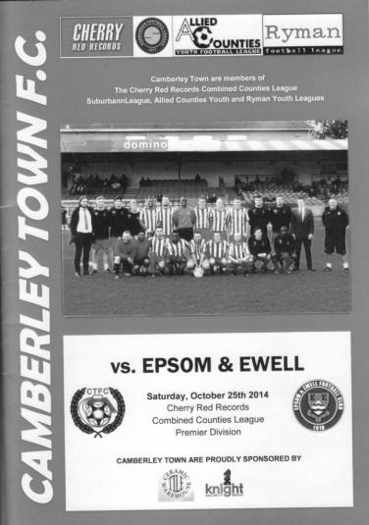
Krooners edge dull encounter

The Salts faced their second title contender in a week when we travelled a well known route to Krooner Park, home of Camberley Town on Saturday and for the second time we came up short, although as with the defeat against Ashford Town, we weren't second best by much.

The continuing absence of Taylor Smith meant a start for Mark Jarman while Ali Dewar returned to the starting eleven at the expense of the suspended Sam Robinson and his brother Matt Robinson dropped into a right midfield position. At the back Dan Dean and Luke Gaffney were absent and Sean White sat on the bench as James Taylor came in as a regulation right back with the returning Matt Tanton in at left back of a 4-4-2 formation. On the bench Manager Glyn Mandeville was away so Matt Smith had his first chance to take charge of the team.

This was not a game for the purists. Camberley are a big physical side that play to their strengths while our boys clearly don't usually play in that style. However, by the end of the game we found ourselves trying the same thing and Kyle Hough and Jarman found themselves looking up a bit too often for their service, which along with a solid defensive performance by our defence ensured that neither team managed a single effort on target in the second half.

There were more opportunities for both sides in the first half although apart from a five minute spell of real threat for us the danger came mostly from the home team. Michael Eacott was in action after just five minutes when a shot came at him and six minutes later a Camberley free kick just cleared our crossbar. Eacott had to parry a powerful shot after seventeen minutes before two almost identical attacks on their right wing resulted in attempts on goal that our keeper was able to deal with fairly comfortably.

After 29 minutes we worked our first real chance of the match when Taylor sent in a dangerous cross from the right but Hough was unable to control the ball without

maybe realising how much space he had at the time and the ball dribbled out for a goal kick. Within a minute Tanton had made similar inroads down the left. He laid the ball back to Matt Farrell whose deep cross was met by Robinson just beyond the far post but his shot was just the wrong side of the junction of post and bar.

This really was a good period of the match for us. With two of the Matt's; Ferdinando and Farrell beginning to get on top in midfield we started to make some more chances. After 37 minutes Dewar broke through on the left and the home defence opened up. All that was required was for our winger to get the ball across the face of goal where Hough was waiting along with the incoming Farrell, but their defender was able to block the ball and the danger was cleared.

Not for long though as Jarman fed Robinson who got away on the right and shot across goal but Dewar was unable to get a good touch on the ball from close range. Jarman then found Hough moments later and he got the ball to Robinson on the right who shot hard and low at goal but his effort was pushed away by their keeper Bradshaw with Jarman unable to do anything from wide with the loose ball.

The home side weathered the storm though and nearly scored with a header that was just over the bar with Eacott appearing to be fouled in the process and after 42 minutes they scored what would prove to be the only goal of the game. It was a form of redemption for their scorer Jamie Hoppitt who had been sent off the last time we visited. A good move on the left resulted in a low delivery but we only half cleared the danger and he forced the loose ball just inside Eacott's right hand post.

Straight from the restart we made a good chance when Jarman got through on goal but he was held up by the defender and then tackled by Bradshaw without managing to get a shot in. Regrettably we failed to hit the target in the second half, although the home side threatened rarely themselves with just a free kick headed off target to either side's credit while Dewar had a powerful shot that just cleared the bar from the edge of the area, but the second half was an uninteresting spectacle with much of the play confined to midfield.

It is fair to say that the home side deserved the points. They created more in the first half and did enough to stop us when we got up a head of steam towards the end of the opening period. However, if I had to compare Camberley with Ashford I would say that the latter's firepower make them the team to watch. Camberley may not be so attractive to the eye but they will be thereabouts again this season.

For our part we now face Chertsey Town before we travel to Lingfield for the important Vase tie and we need to get back on the winning trail as soon as possible.

Team: Michael Eacott, James Taylor, Matt Tanton, George Murphy, Anthony Panayi ©, Matt Ferdinando, Matt Robinson, Matt Farrell, Mark Jarman, Kyle Hough, Ali Dewar

Subs: Dale Marvell for Jarman (74), Sean White for Dewar (79),
Ollie Shaw for M.Robinson (90)

Club Records - 28th October
Date | Day | Competition |  | Opponents |  | Scorers
28/10/33 | Sat | F.A. Cup 3q | A | Beddington Corner | 4-2 | A.Rance, L.Marlow, L.Graves, J.Jones
28/10/50 | Sat | Surrey Senior Cup 3q | H | Devas Institute | 3-2 | S.Faggetter, P.Jordan, F.Boatwright (pen)
28/10/61 | Sat | Amateur Cup 2q | H | Addlestone | 1-3 | B.Robinson
28/10/67 | Sat | Surrey Senior Cup 2q | H | Banstead Athletic | 1-2+ | o.g.
28/10/72 | Sat | Athenian League 2 | A | Edgware | 1-1 | B.Langton
28/10/78 | Sat | Isthmian League 1 | A | Maidenhead United | 0-1
28/10/80 | Tue | Isthmian League 1 | H | Kingstonian | 2-2 | A.Venturini (pen), T.Coombe
28/10/85 | Mon | Isthmian League  Premier Division | A | Dulwich Hamlet | 3-5 | R.Kidd (pen), T.Tuite, P.Kemp
28/10/89 | Sat | Isthmian League 2s | A | Eastbourne United | 0-1
28/10/95 | Sat | Isthmian League 3 | A | Tring Town | 1-1 | S.Smith
28/10/97 | Tue | Surrey Senior Cup Preliminary Round | H | Egham Town | 1-3 | D.Arkwright
28/10/03 | Tue | Isthmian League Cup Preliminary Round | H | Waltham Forest | 0-1
28/10/06 | Sat | Combined Counties Premier Division | H | Wembley | 2-3 | D.Marvell, A.Pero
28/10/08 | Tue | Combined Counties Premier Division | A | Wembley | 5-0 | K.Hough (2), R.Burns (2), D.Marvell
Historical Decades
90 years ago – Epsom Town
25/10/24 | Sat | Amateur Cup 2q | H | West Norwood | 3-0 | R.Marlow (2), T.Kirk
80 years ago – Epsom F.C.
27/10/34 | Sat | London League | A | Grays Athletic | 2-2 | J.O'Connor, E.Hannam
70 years ago – War time Epsom Town
28/10/44 | Sat | South Eastern  Combination | H | Tooting & Mitcham United | 1-4 | H.Bridge
60 years ago – Epsom F.C.
30/10/54 | Sat | Corinthian League | A | Maidstone United | 1-4 | R.Ballard
50 years ago – Epsom & Ewell
31/10/64 | Sat | Surrey Senior Cup 2q | A | Westfield | 1-5 | D.Bruce
40 years ago – Epsom & Ewell
26/10/74 | Sat | F.A. Vase 1 | H | Reigate Priory | 4-0 | D.Worby, J.Eales (2), P.Walker
30 years ago – Epsom & Ewell
27/10/84 | Sat | Isthmian League  Premier Division | A | Billericay Town | 0-1
20 years ago – Epsom & Ewell
26/10/94 | Wed | Isthmian League 3 | A | Collier Row | 1-5 | A.Nimmo
10 years ago – Epsom & Ewell
27/10/04 | Wed | Isthmian League Cup 1 | H | Witham Town | 1-2 | A.Stones

History Corner – 28th October
90 years ago this week we played our very first Amateur Cup tie against West Norwood, winning 3-0. Having a bye in the first qualifying round, we were drawn at home but our ground at Horton Hospital Sports Grounds was not enclosed and we were unable to take a gate. As a result we were obliged to switch the tie to their home venue of Gorringe Park but it made no difference in the end as the Athenian League side, two levels above us, were beaten comfortably, although Redhill ended the interest by five clear goals in the next round.

80 years ago this week we had another fixture that required a switch. This time it was an away game at Beddington Corner and it was a big F.A. Cup tie so with their inability to collect a gate the match was switched to West Street. Our 4-2 win would enable us to enter the final qualifying round for the first time, but more about that in the next home programme!

70 years ago today our war time team hosted Tooting & Mitcham United, the form team in those days, and they defeated us by four goals to one with Bob Parker scoring all four for them.

47 years ago today we hosted Banstead Athletic in the Surrey Senior Cup. Playing for them was Ernie Watkins, who had been released by Epsom in 1960 on the basis that he was a bit too old! After seven further years at Merland Rise, the forty-seven year old was made Captain for the day and played brilliantly throughout a match that required extra time as they defeated us 2-1. How about that for revenge!

40 years ago this week the famous run began when we hosted tiny Reigate Priory at West Street and defeated them 4-0 in the First Round of a new competition, the F.A. Vase. It didn’t mean much at the time, sandwiched in between two matches where we had scored nine, but it would turn out to become far more important as the season went on. (see programme right)

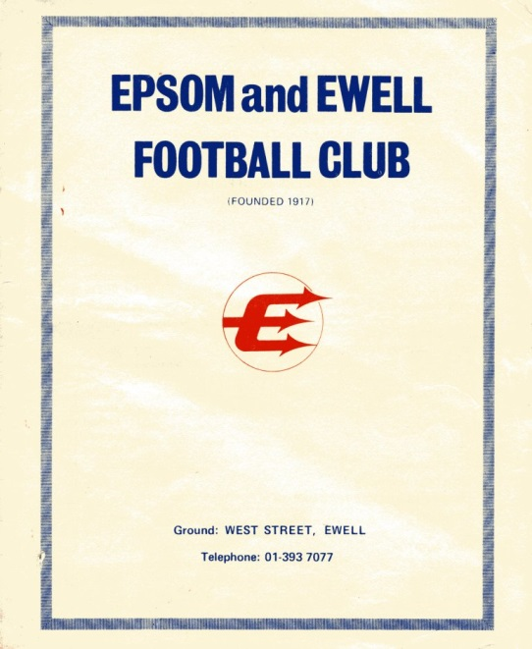
6 years ago today we won our first match at Wembley’s Vale Farm ground since 1962. We had started the season with an eleven match unbeaten run but with our record at Wembley, we had to be clinical, and we were, leading in the first minute and 4-0 at half time, finishing up as 5-0 winners and sitting on top of the table. It all went pear shaped four days later as we lost at North Greenford and we finished fourth in the end.

Chertsey Town – History
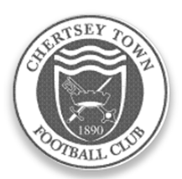
Organised football was evident in Chertsey well over a century ago but county affiliation did not take place immediately. The official founding of the club took place in 1890 when matches were played in the West Surrey League. The first success came in 1897 when the Surrey Junior Cup was secured. A one year gap took place before football resumed in the same competition which eventually became the East and West Surrey League.

A further halt in football took place during the Great War but soon after, in 1919, the club joined the Surrey Intermediate League where it stayed uneventfully, until 1939 and a further break. An invitation to become founder members of the Surrey Senior League was not taken up in 1923 but membership was later assumed, on attaining senior status in 1946.

The club has played at various locations within the parish (Willow Walk, Free Prae Road, Stained Lane and Chilsey Green Road) before settling down at the present home in 1929. The suffix ‘Town’ was added to its title some 21 years later. The ground was donated by Sir Edward Stern as a football ground to the ‘premiere club in the parish’. Next door, a similar trust provides facilities for Chertsey Cricket Club. The main stand was constructed in the mid fifties; the original clubhouse added in 1960 and the first covered enclosure was built some three years later. Cover behind one goal was added in 1994.

Although Chertsey gained membership of the Surrey Senior League immediately after the Second World War, it was not until the 1959/60 season that success came with the league championship. This was repeated twice in the next three years, a halcyon period when the League Cup was also won on three occasions. Due to the static nature of amateur football in those days, the club could not progress to the preferred Corinthian League so, in 1963, it was controversially decided to turn professional and enter the Metropolitan League. Although an entertaining three years were then enjoyed, the cost was too much to bear and a return to lower levels of the Greater London League for one season occurred before a further shift to the Spartan League was made in 1967.

Indifferent results then dogged the club for almost two decades. This situation was briefly relieved in 1974/75 when the club were League and League Cup

runners up to an up and coming Farnborough Town. Meanwhile, the fabric of the club was being built up behind the scenes and despite the lack of prominence on the park, movement was made via the London Spartan (1975/76) and Athenian leagues through to the Isthmian family with a place in Division Two South in 1984. Instant relegation to the Combined Counties League was suffered but, a rejuvenated side won promotion back to the Isthmian ranks within the year winning the League Cup on the way.

The club was rewarded with good league positions but further promotion denied at first. The worst season after returning to the Isthmians came when the two Division Twos were split in 1991 and a place in the new Division Three had to suffice. The position was quickly rectified with a runner’s up slot in 1992. The club also reached the quarter finals of the FA Vase, emulating a similar performance in 1987/88. One year later 102 points and a runner’s up promotion place to Division One was nailed. The League Cup was also secured together with the Carlsberg trophy in the same campaign along with the League Charity Shield.

Only one campaign was required in Division One before further promotion to the Premiere Division. The first season at that level was one of consolidation but the second was more difficult. A late rally was experienced, but was insufficient to avoid the drop to Division One. Two subsequent Division One campaigns were comfortable but the third proved too difficult after a very poor first half of the season.

Relatively respectable positions were attained for the next two seasons and then a return to Division One, taking a place in the revised south section in the Isthmian re-organisation. The side was not able to compete at this level and relegation to Division Two was suffered in 2003. With the dissolution of the division, the club was allocated to Combined Counties in 2006. Promotionally hopeful situations were created regularly over the five terms in that competition. Finishing as runners up in 2011 was good enough on that occasion to secure promotion to Division One Central of the Southern League. Unspectacular, but safe, performances were achieved for two seasons but the relegation was suffered at the end of last season, and with it a return to the Combined Counties League.

The team manager’s role was taken over in the 2014 close season by Kim Harris. The Chairman is Steve Powers.

Centre page for results

Centre page for results

EL Records Premier Challenge Cup
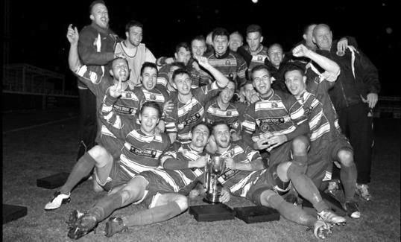
Second Round
Alton Town | 13/12 | Farnham Town
Ashford Town (Mx) | 5-0 | CB Hounslow United
Badshot Lea | 10-2 | Dorking
Bedfont Sports | 1-1+ | Cove
Cove won 4-1 on penalties
Camberley Town | 0-0+ | Molesey
Camberley Town won 3-0 on penalties
Chertsey Town | 0-7 | Windsor
Cobham | 4/11 | Horley Town
Colliers Wood United | 3-0 | Bedfont & Feltham
Epsom & Ewell | 2-1 | Knaphill
Epsom Athletic | 19/11 | Banstead Athletic
Eversley & California | 2-4 | Ash United
Frimley Green | 1-0+ | Spelthorne Sports
Hanworth Villa | 11/11 | Guildford City
Sheerwater | 1-6 | Mole Valley SCR
Westfield | 4-0 | Farleigh Rovers
Worcester Park | 29/11 | Chessington & Hook United
Third Round
Westfield | 18/11 | Cove
Badshot Lea | V | Hanworth Villa / Guildford City
Worcester Park / Chessington & Hook | V | Epsom Athletic / Banstead Athletic
Alton Town / Farnham Town | V | Mole Valley SCR
Frimley Green | 9/12 | Epsom & Ewell
Windsor | 2/12 | Ash United
Colliers Wood United | V | Cobham / Horley Town
Camberley Town | 9/12 | Ashford Town (Mx)

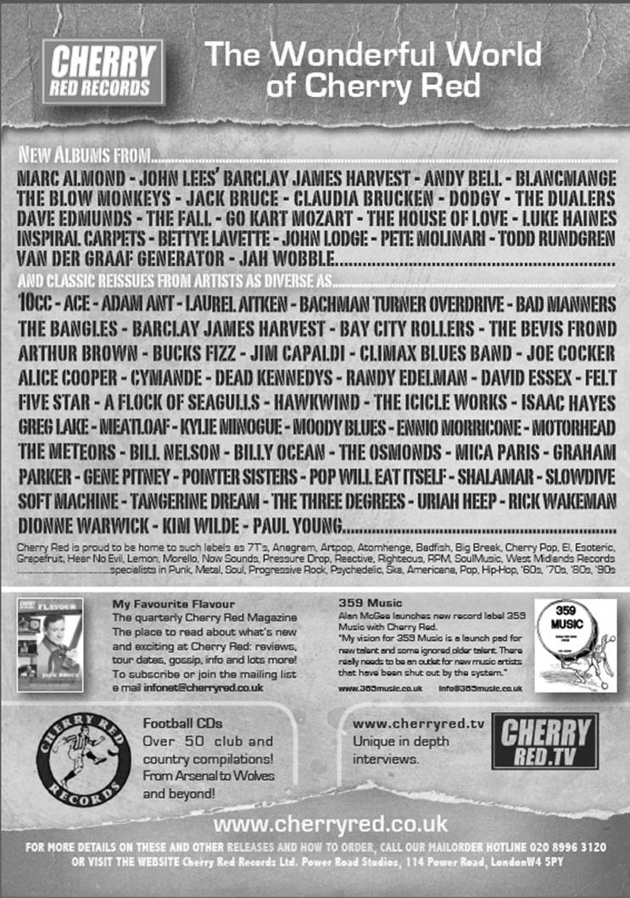
Player Sponsorship
Here is the latest list showing all of the players and Management available for sponsorship. Sponsorship costs £40 so if you want to help the club, the player and get your name in the programme for the season, just let us know.

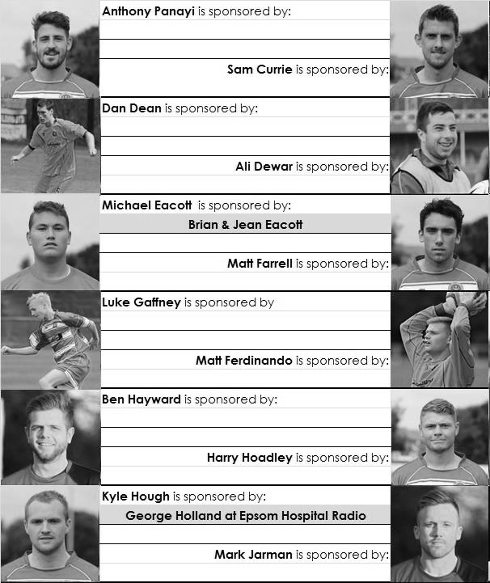

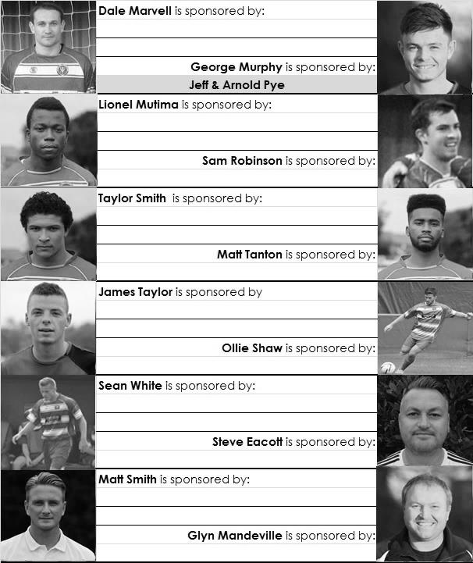

We are not fussy; we’ll take cash or a cheque! Any donation will help the club and is much appreciated.

Every Opponent A-Z
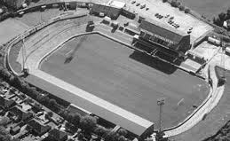
Over the years we have played many, many different opponents. Exactly how many is a difficult question, as it all depends on your definition. Are Camberley & Yorktown different to Camberley Town, or are Epsom Town different to Epsom F.C. or Epsom & Ewell F.C.?

In my analysis I have classed them as the same team, and will work through them all from A to Z. Some we have played many times, whilst others we have met maybe just once or twice. Enjoy!

Maidstone United: Played 14 - W5 D2 L7 - F31 A33 - PPG - 1.21 - Below Average

The old Maidstone United ground at London Road

It may be hard to believe but back in the fifties, both we and Maidstone United were at the same level and competed in seven seasons of Corinthian League football.

We first met in season 1950/51 when Maidstone had the misfortune to finish at the foot of the table. Bizarrely though, their Reserves were Champions of their Section!

Their Captain at the time was one Gordon Jago, who would go on to become Millwall Manager, famously returning to our club in 1975 to sign Trevor Lee and Phil Walker. But they were a poor side that season and a Freddie Boatwright hat trick helped us on our way to a 6-2 win at West Street the first time that we met, on 23rd December 1950.

The return fixture finished 3-3 on our first visit to London Road after we recovered a 3-1 half time deficit, but although we didn’t know it at the time, this would be as close as we would get to ever winning there as six losses from six trips would be our return from

that point. At West Street though, our ground was like a fortress and it would not be until their seventh and final visit that they would succeed there, following five Epsom wins and a draw, most notably a 5-0 thrashing on 3rd December 1955.

The final season of meetings, 1956/57 needs further description. Our final visit to London Road started badly as we trailed 3-0 early on, but striker Johnny Bangs scored a hat trick on his debut to level the scores before we fell away at the end to lose 5-3.

Our final meeting on 4th May was a real anti-climax. We were in with a shout of the Corinthian League double with a week to go. However, a 2-0 loss to Maidenhead United was then followed by home and away defeats to Eastbourne which meant that by the time we faced the Stones we could no longer win the title. This was embarrassing as the programme had to go to the printers before the final Eastbourne match and was classed as a “souvenir programme” on the cover to mark something that wouldn’t occur!

Maidstone then won 3-1 and moved up to the Athenian League for two years before becoming an Isthmian League club, a Southern League club, an Alliance Premier League club and a Football League club in that order before it all came crashing down around them, leading to their departure from London Road to Watling Street, home of Dartford F.C. who they promptly took under with them in 1992!

Nine long years passed before the name of Maidstone United resurfaced in the Kent League. The club had reformed almost immediately, under the name of Maidstone Invicta, and were playing next door to the old London Road stadium, on the old reserve pitch. When they rejoined the Kent League they had to have a ground of a sufficient standard and shared with Sittingbourne. After a year, both they and their landlords decamped from the vast Central Park to the more compact but cheaper to run Bourne Park sitting in its shadow.

They rejoined the Isthmian League in 2006 and their new Gallagher Stadium (pictured) complete with 3g pitch facility opened in July 2012. They currently lead the way both on the pitch and off it and have recently persuaded the Conference to accept 3g surfaces. Just as well as they could be in the Conference South next season!

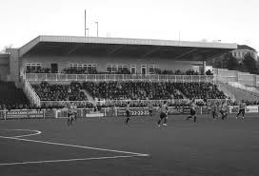

Match and Ball Sponsorships – 2014/15
Opponent | Date | Match Sponsor | Ball Sponsor
Raynes Park Vale | 05/08/14 | Club President - Stella Lamont
Horley Town | 25/08/14 | Epsom & Ewell F.C. Management Committee
Croydon (FAC) | 30/08/14 | Media Officer - Richard Lambert
Frimley Green | 13/09/14 | Dave Gaffney and friends
Guildford City | 30/09/14 | The Jarman family
Mole Valley SCR | 07/10/14 | Mark and Carmel Murphy
Bedfont Sports | 11/10/14 | Epsom & Ewell F.C. Colts
Knaphill (LC) | 14/10/14 | Geoff and Steve Dyke
Ashford Town (Mx) | 18/10/14 | The Building Shop, Bookham
Chertsey Town | 28/10/14 | In Memory of Bob Bexley
Molesey | 22/11/14 | Provisional and dependent on any Vase progress
Camberley Town (SSC) | 02/12/14
Hanworth Villa | 06/12/14
Windsor | 03/01/15
Farnham Town | 17/01/15
Westfield | 31/01/15
Camberley Town | 07/02/15
Hartley Wintney | 21/02/15
Cove | 07/03/15
Badshot Lea | 21/03/15
Colliers Wood United | 04/04/15
Knaphill | 18/04/15
Spelthorne Sports | tba
For League, League Cup and Surrey Senior Cup Matches:

Match sponsorship - £40.00 Match ball sponsorship - £25.00.
Combined Offer of Match and Match Ball sponsorship for £55.00.

For F.A. Cup and F.A. Vase matches:

Match sponsorship - £50.00 Match ball sponsorship - £30.00.
Combined Offer of Match and Match Ball sponsorship for £65.00.
----------------------------------------------------------------------------------------------------------------------------
Sponsorship includes

Admission, programmes, advertising (if required) and hospitality.

If you are interested, just speak to a Committee Member, you know where we are!
Alternatively, drop me an email at: richard.c.lambert@gmail.com

Club Directory
ASHFORD TOWN (Mx) Telephone: 01784-245908 - Ground: The Robert Parker Stadium, Short Lane, Stanwell. TW19 7BH - Colours: Tangerine & White Stripes/Black/Tangerine

BADSHOT LEA Telephone: 01252-320385 - Ground: Ash United FC, Shawfield Stadium, Youngs Drive, Shawfields Road, Ash, Hampshire. GU12 6RE - Colours: Claret/White/Claret

BEDFONT SPORTS Telephone: 0208-831-9067 - Ground: Bedfont Sports Club, Hatton Road, Bedfont, Middx TW14 8JA - Colours: Red & Black Hoops/Black/Red & Black Hoops

CAMBERLEY TOWN Telephone: 01276-65392 - Ground: Krooner Park, Wilton Road, Camberley, Surrey. GU15 2QW - Colours: Red & White Stripes/Blue/Red

CHERTSEY TOWN Telephone: 01932-561774 - Ground: Alwyns Lane, Chertsey, Surrey. KT16 9DW Colours: Royal Blue & White Stripes/Royal Blue/Royal Blue

COLLIERS WOOD UNITED Telephone: 0208-942 8062 - Ground: Wibbandune Sports Ground, Lincoln Green, Opposite 199-213, Robin Hood Way, Wimbledon. SW20 0AA - Colours: Blue & Black Stripes/Black/Black

COVE Telephone: 01252-543615 - Ground: Oak Farm Fields, 7 Squirrel Lane, Cove, Farnborough, Hampshire. GU14 8PB - Colours: Yellow/Black/Yellow

EPSOM & EWELL Telephone: 01737-553250 - Ground: Chipstead FC, High Road, Chipstead, Surrey. CR5 3SF - Colours: Royal Blue & White Hoops/Royal Blue/Royal Blue & White Hoops

FARNHAM TOWN Telephone: 01252-715305 Ground: Memorial Ground, Babbs Mead, West Street, Farnham, Surrey. GU9 7DY Colours: - Claret & Sky Blue /White/ Claret & Sky Blue

FRIMLEY GREEN Telephone: 01252-835089 - Ground: Frimley Green Recreation Ground, Frimley Green Road, Frimley Green, Camberley, Surrey. GU16 6JY - Colours: Blue & White/Blue/Blue

GUILDFORD CITY Telephone: 01483-443322 - Ground: The Spectrum, Parkway, Guildford, Surrey. GU1 1UP - Colours: Red & White Stripes/Black/Black

HANWORTH VILLA Telephone: 0208-831-9391 - Ground: Rectory Meadows, Park Road, off Hounslow Road, Hanworth, Middlesex. TW13 6PN - Colours: Red & White Stripes/Black/Black

HARTLEY WINTNEY Telephone: 01252-843586 - Ground: Memorial Playing Fields, Green Lane, Hartley Wintney, Hants RG27 8DL - Colours: Orange & Black/ Orange /Orange

HORLEY TOWN Telephone: 01293-822000 - Ground: The New Defence, Anderson Way, Court Lodge Road, Horley, Surrey. RH6 8SP - Colours: Claret & Sky Blue/Claret/Claret

KNAPHILL Telephone: 01483-475150 - Ground: Brookwood Country Park, Redding Way, Lower Guildford Road, Knaphill, Surrey. GU21 2AY - Colours: Red/Black/Red

MOLE VALLEY SCR Telephone: 01932-866386 - Ground: Cobham FC, Leg O’Mutton Field, Anvil Lane, Downside Bridge Road, Cobham, Surrey KT11 1AA - Colours: Yellow/Black/Black

MOLESEY Telephone: 0208-979-4283 - Ground: 412 Walton Road, West Molesey, Surrey KT8 2JG Colours: White/Black/Black

RAYNES PARK VALE Telephone: 020-8540-8843 - Ground: Prince Georges Playing Field, Grand Drive, Raynes Park, London. SW20 9NB - Colours: Blue/Blue/Red

SPELTHORNE SPORTS Telephone: 01932-961055 - Ground: Spelthorne Sports Club, 296 Staines Road, Ashford Common, Ashford, Middx. TW15 1RY - Colours: Light & Dark Blue/Dark Blue/Light Blue

WESTFIELD Telephone: 01483-771106 - Ground: Woking Park, Kingfield Road, Woking, Surrey. GU22 9BA - Colours: Yellow/Black/Black

WINDSOR Telephone: 01753-860656 - Ground: Stag Meadow, St Leonards Road, Windsor, Berks SL4 3DR - Colours: Red/Red/Red

Surrey Senior Cup
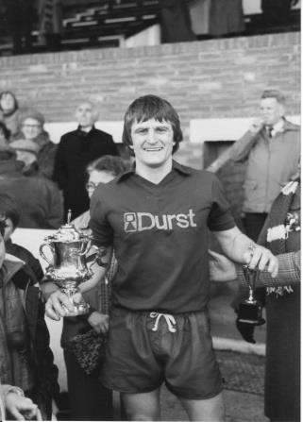

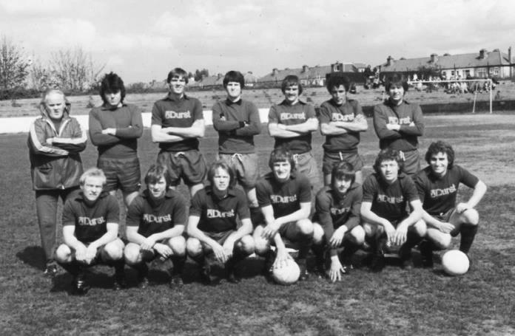
First Round
Carshalton Athletic | 1-2 | Egham Town
Croydon | 0-0+ | Colliers Wood United
Colliers Wood United won 4-3 on penalties
Merstham | 2-1 | Whyteleafe
Raynes Park Vale | 2-0 | Chertsey Town
South Park | 2-1 | Guildford City
Second Round
Lingfield | V | Westfield
Redhill | V | Raynes Park Vale
AFC Wimbledon | V | Chipstead
Godalming Town | 11/11 | Mole Valley SCR
Knaphill | V | Colliers Wood United
Metropolitan Police | V | Walton & Hersham
Epsom & Ewell | 2/12 | Camberley Town
Leatherhead | 26/11 | Farnham Town
Merstham | V | Beckenham Town
Molesey | V | Egham Town
South Park | V | Sutton United
Walton Casuals | 25/11 | Corinthian Casuals
Badshot Lea | 2/12 | Kingstonian
Dorking Wanderers | V | Frimley Green
Tooting & Mitcham United | V | Horley Town
Woking | 4/11 | Ashford Town (Mx)

Our New Website
Have you seen our website?

For those who are unaware, our website, now over a year old, contains everything you could possibly want to know about the club and an enormous amount you may not have been aware of!

Our previous site still exists, but as a photo archive only, housing the enormous wealth of pictures provided by Gemma Jarman, our Club photographer. In addition, there are over a thousand historical images of teams, players, action shots and programme covers.

As you can tell from the screenshot of our front page, there is a substantial amount of information all available at the touch of a button, which is also very useful if you own one of those new touchscreen personal computers that are becoming more and more popular these days.

If you are a supporter, please pass the address on to anyone you know that has ever expressed an interest in the club, especially those who don’t visit any more. You never know, some of them might be inspired to come along too, and bring their friends etc.

http://www.eefconline.co.uk/

F.A. Vase
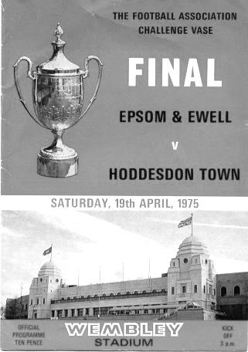
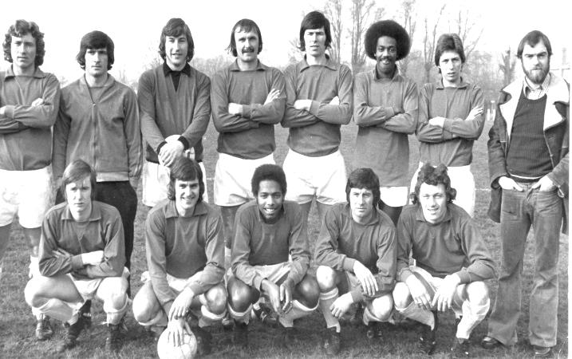
Second Qualifying Round – 4th October
Colliers Wood United | 2-1 | Shoreham
Cray Valley (PM) | 0-2 | Horley Town
Farnham Town | 2-1 | Milton United
Flackwell Heath | 5-0 | Frimley Green
Highworth Town | 2-1+ | Hartley Wintney
Spelthorne Sports | 2-1 | Risborough Rangers
Molesey | 1-2 | Greenwich Borough
Raynes Park Vale | 2-1 | Epsom Athletic
Rothwell Corinthians | 0-1 | Bedfont Sports
Windsor | 4-0 | Binfield
Woodley Town | 0-2 | Knaphill
First Round Proper – 1st November
Ashford Town (Mx) | V | Loxwood
Chertsey Town | V | Horley Town
Chessington & Hook United | V | Camberley Town
Colliers Wood United | V | Ringmer
Farnham Town | V | Abingdon United
Horsham YMCA | V | Bedfont Sports
Lingfield | V | Epsom & Ewell
Littlehampton Town | V | Guildford City
Lordswood | V | Knaphill
Pagham | V | Spelthorne Sports
Raynes Park Vale | V | Westfield
Windsor | V | Highworth Town
Hanworth Villa are exempted to the Second Round

Scouting the Opponent – Lingfield F.C.
With my supporter’s hat on, the F.A. draws have been kind to us. In the Cup we were sent to Hassocks for the first time and now in the Vase our First team make their inaugural visit to Lingfield this coming Saturday.

Lingfield have been around for years, being formed back in 1893 and although entering the Surrey Senior Cup, have spent much of their recent history as members of the Sussex League. As of this season though it was pastures new as they were transferred along with Croydon from our League into the Southern Counties East League, the not very user-friendly name of the former Kent League.

Situated just over a mile away, as the crow flies, from the Lingfield Park race course, the Lingers have shared with the local cricket ground for a while now. The venue is not completely unknown to our club as our Reserves went there twice in Suburban League competition in 2010/11 and 2011/12, winning 4-2 and then losing 0-9 when admittedly we played with nine men throughout!

They currently have the worst defensive record and the worst goal difference in the division, but they have scored the second most number of goals, so there should be excitement when we meet!
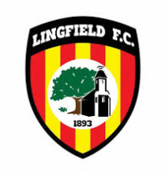
The main stand at Godstone Road; home to Lingfield F.C.

Southern Counties East League Table
inc Saturday 25th October | P | W | D | L | F | A | Pts | GD
Erith & Belvedere | 14 | 12 | 1 | 1 | 45 | 13 | 37 | 32
Ashford United | 15 | 7 | 7 | 1 | 30 | 16 | 28 | 14
Phoenix Sports | 11 | 8 | 3 | 0 | 23 | 5 | 27 | 18
Beckenham Town | 13 | 7 | 3 | 3 | 30 | 18 | 24 | 12
Tunbridge Wells | 15 | 7 | 3 | 5 | 23 | 19 | 24 | 4
Canterbury City | 13 | 7 | 2 | 4 | 21 | 19 | 23 | 2
Lordswood | 13 | 6 | 3 | 4 | 17 | 20 | 21 | -3
Sevenoaks Town | 12 | 6 | 2 | 4 | 19 | 18 | 20 | 1
Corinthian | 11 | 6 | 0 | 5 | 26 | 22 | 18 | 4
Holmesdale | 12 | 5 | 2 | 5 | 30 | 20 | 17 | 10
Crowborough Athletic | 14 | 5 | 1 | 8 | 29 | 36 | 16 | -7
Lingfield | 14 | 5 | 0 | 9 | 31 | 50 | 15 | -19
Woodstock Sports | 13 | 4 | 2 | 7 | 17 | 23 | 14 | -6
Fisher | 12 | 4 | 2 | 6 | 15 | 30 | 14 | -15
Greenwich Borough | 7 | 4 | 1 | 2 | 13 | 10 | 13 | 3
Cray Valley (PM) | 14 | 3 | 3 | 8 | 33 | 35 | 12 | -2
Croydon | 12 | 3 | 2 | 7 | 14 | 21 | 11 | -7
Rochester United | 14 | 3 | 2 | 9 | 23 | 37 | 11 | -14
Erith Town | 15 | 2 | 3 | 10 | 18 | 31 | 9 | -13
Deal Town | 12 | 2 | 2 | 8 | 8 | 22 | 8 | -14

Combined Counties League – Premier Division
Tuesday, 28th October 2014 - Kick-off 7.45 p.m.
Epsom and Ewell  (Royal Blue & White hoops) | V |  | Chertsey Town  (All Red)
 | NUMBERS
Michael Eacott |  |  | Luke Daley
James Taylor |  |  | Steve Newman
Luke Gaffney |  |  | Lewis Taylor
© George Murphy |  |  | Danny Alderton
Dan Dean |  |  | Anthony Glover
Matt Tanton |  |  | William Borr
Matt Ferdinando |  |  | Kieron Woodley
Matt Farrell |  |  | Jack Wadmore
Taylor Smith |  |  | John Pomroy
Kyle Hough |  |  | Luke Jones
Dale Marvell |  |  | Joe Jones
Matt Robinson |  |  | Ben Ewing
Lionel Mutima |  |  | Kristian Childs
Sean White |  |  | Festus Lori
Ollie Shaw |  |  | Filippo Di Bonito
Anthony Panayi |  |  | Michael White
Ben Hayward |  |  | Al Brown
Ali Dewar |  |  | Scott Harris
Mark Jarman |  |  | Michael Garrick
Sam Robinson |  |  | Ibrahim Meite
Glyn Mandeville | MANAGER |  | Kim Harris
Matt Smith | ASSISTANT |  | Perry Gough
Steve Eacott / Alex McKay | COACHES
Ken Jones | PHYSIO
REFEREE: M.Coen (Worcester Park)
ASSISTANTS: K.Corrick (Oxted), S.Earl (Mitcham)
Today’s Match and Match Ball are sponsored
In memory of Bob Bexley

OUR NEXT VISITORS TO HIGH ROAD (provisionally)
Molesey
Saturday 22nd November 2014 - Kick-off 3.00 p.m.
Combined Counties League – Premier Division

